LAB Logbook
Lab 6
*Plot of the 2nd model's summary
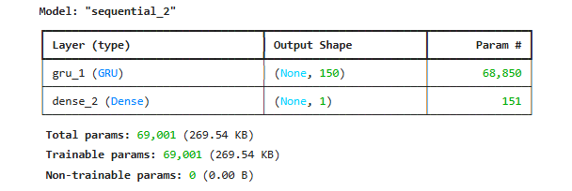
*Copy of early-stop code and history_2 fit-training-process
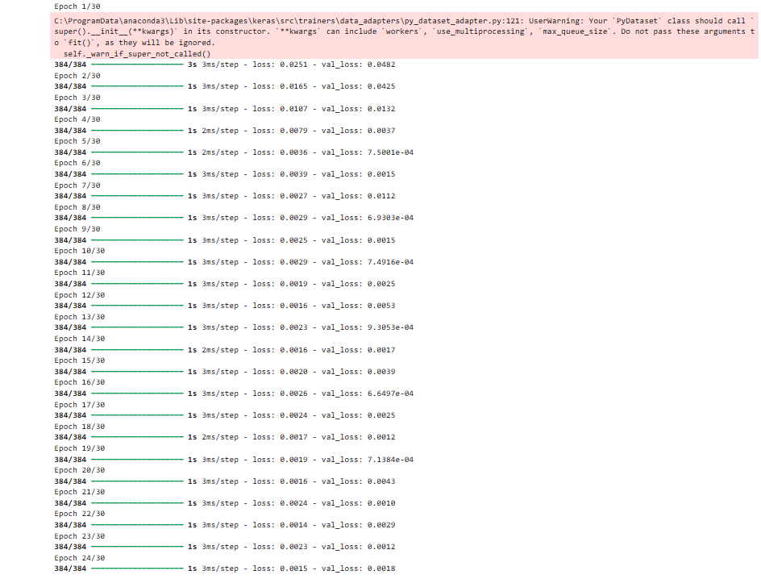
*Plot of validation and test loss of history_2
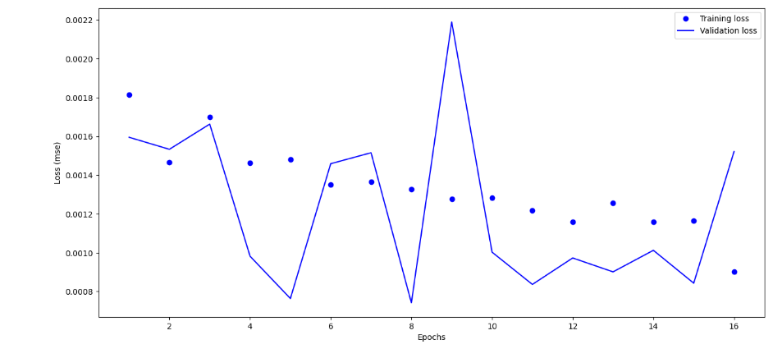
*The optimal number of epochs for training model
Ans : 4

